**Phase 3 - The Enlightenment**

1. **Team:** Team 2
2. **Member Names**
   * Ming-Yeh Chiang
   * Jake Chan
   * Pravalli Budida
   * Mustafa Bhavanagarwala
   * Zehao Chi
3. **Site Name**

SeattleSpots

1. **Site URL**

<http://18.188.22.173/>

1. **Site Mission Statement** – 1 sentence

Our website is dedicated to showcasing the best travel attractions in Seattle and Washington state, offering visitors a comprehensive guide to must-visit locations, hidden gems, and cultural landmarks.

1. **Site Content Strategy** – Site Content Strategy – multiple paragraphs with images (find at least two other real-world examples, web sites, you can analyze/learn; example sites are not necessarily same as design strategy examples). Must discuss contents added/updated in your CMS.

## **Overview**

A strong **site content strategy** ensures that websites engage visitors with **well-structured, visually rich, and frequently updated content**. The key components of a successful content strategy include:

* **Multiple paragraphs with images** to break up information and enhance readability.
* **Real-world examples and analysis** to provide context and credibility.
* **Consistent updates** to keep the site relevant and engaging.

## **Two Real-World Examples of Effective Content Strategy**

### **1. Atlas Obscura (**[**https://www.atlasobscura.com/**](https://www.atlasobscura.com/)**)**

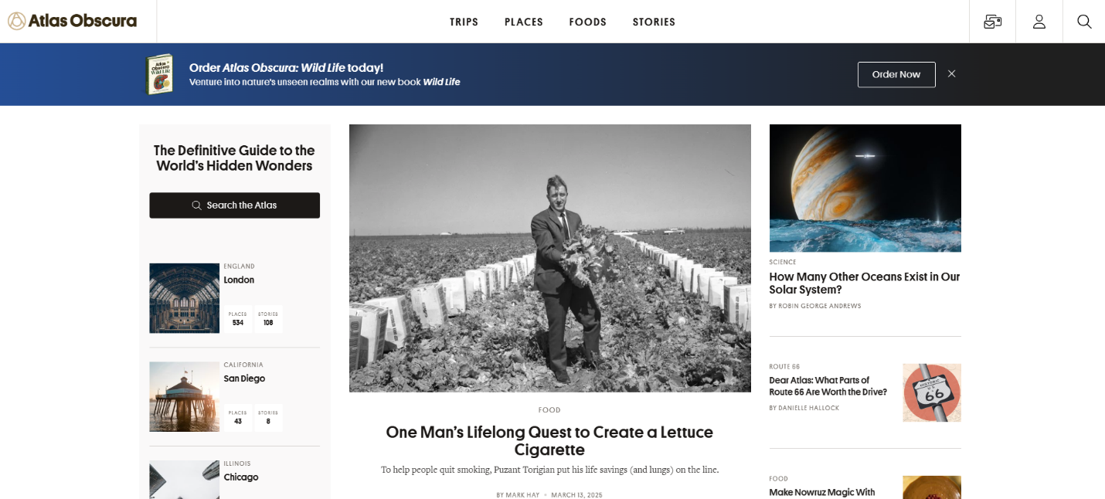

**Why it’s effective:**

* **Focus on Hidden & Unusual Travel Spots** – The site features **offbeat** destinations and little-known attractions.
* **Structured & Engaging Articles** – Each article contains:
  + A **compelling introduction** that hooks the reader.
  + **Multiple images** showcasing the destination.
  + **Detailed descriptions** explaining historical and cultural significance.
  + A **map feature** that helps users locate the attraction.
* **User-Generated Content** – Travelers can contribute their own discoveries, fostering **community engagement**.
* **Frequent Updates** – New and trending locations are regularly added.

### **2. Roadtrippers (**[**https://roadtrippers.com/**](https://roadtrippers.com/)**)**

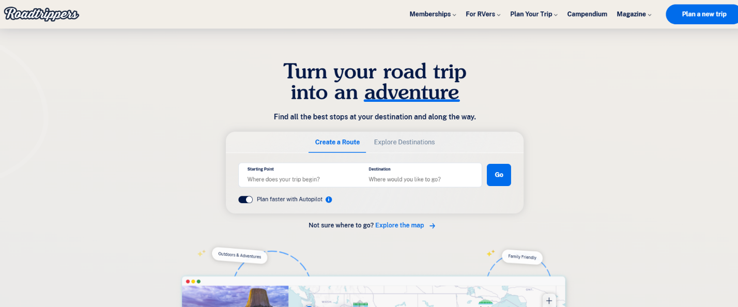

**Why it’s effective:**

* **Interactive Road Trip Planning** – Users can **customize their routes** with **recommended stops**.
* **Well-Structured Blog Posts** – Articles include:
  + **Multiple images** showcasing destinations.
  + **Step-by-step guides** for planning road trips.
  + **Personal travel stories** for a relatable experience.
* **Diverse Travel Topics** – Covers **national parks, hidden gems, and scenic road trips**.
* **Regular Content Updates** – The site continuously adds new **travel routes and itineraries**.

## **New Content Added to the Site**

### **1. Expanded Travel Content**

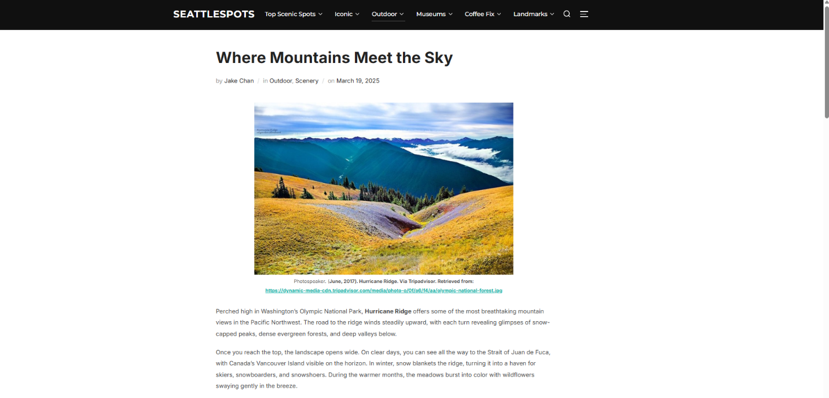

* The site now covers **a wider range of destinations**, including:
  + **Deception Pass State Park** – A nature-rich park with scenic trails.
  + **Snoqualmie Falls** – A famous Washington waterfall with cultural significance.
  + **Puget Sound Express** – A wildlife tour experience featuring marine life.
  + **Hurricane Ridge** – A breathtaking mountain destination.
  + **Ruby Beach** – A coastal escape known for its otherworldly beauty.
  + **Hoh Rain Forest** – A lush rainforest with indigenous history.
  + 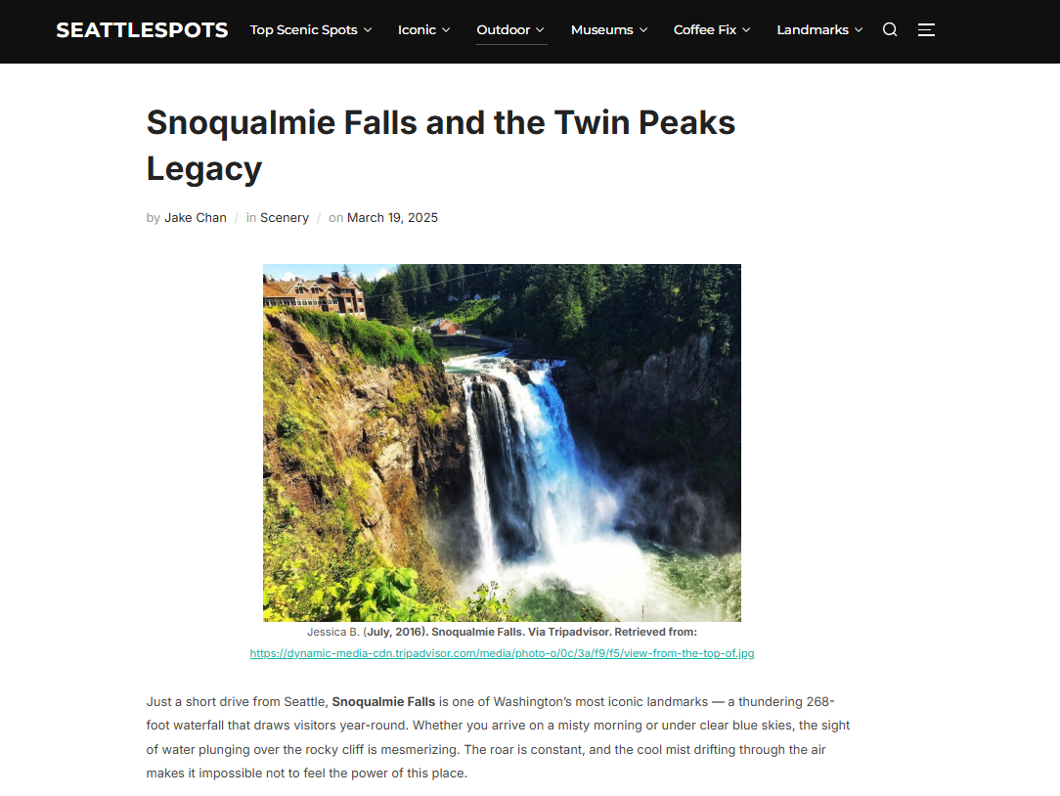
  + 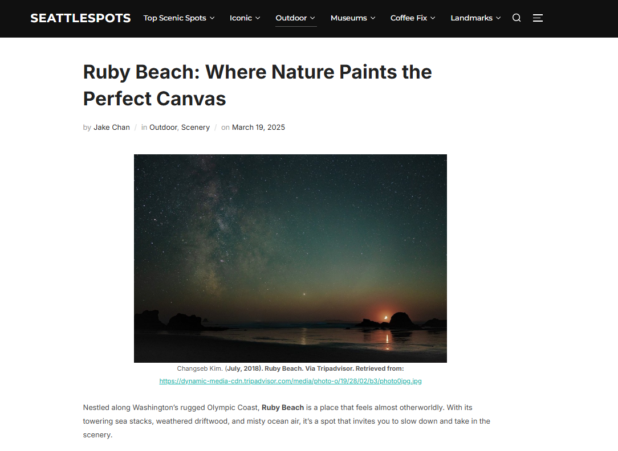

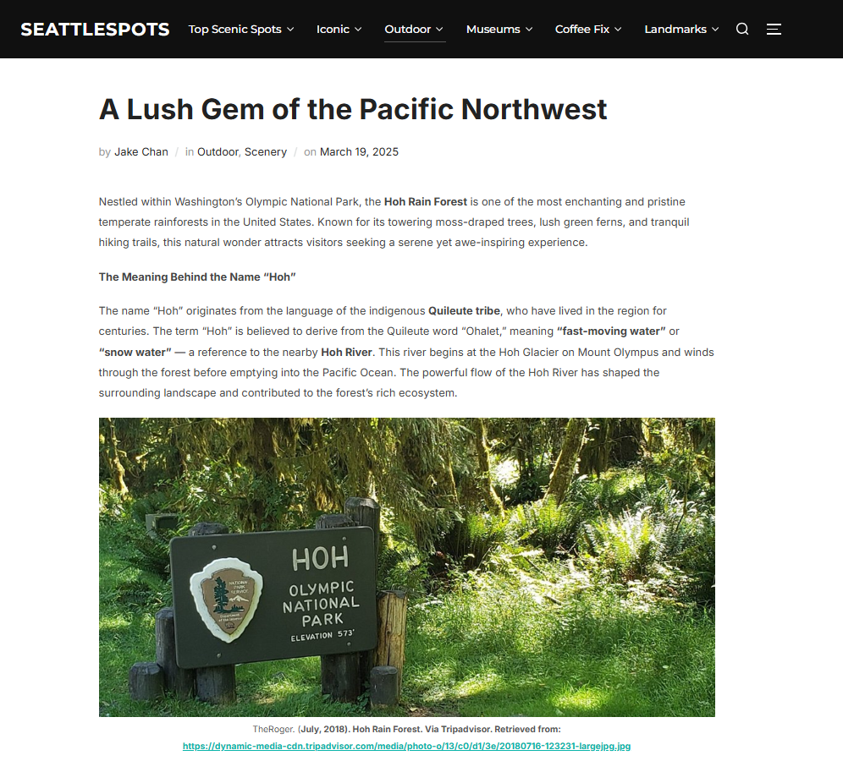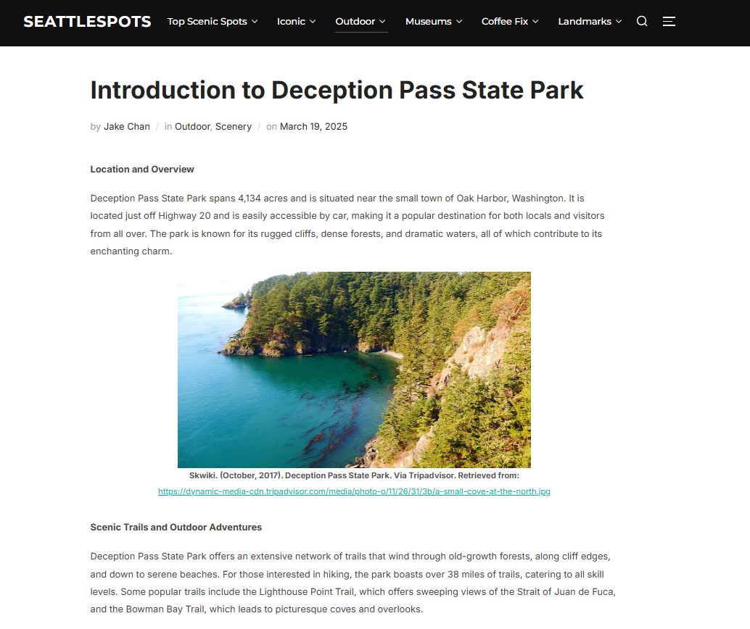

**2. Enhanced Visual Appeal**

* **Each post includes high-quality images** showcasing the destination.
* **Images are well-integrated** into the content, making the articles more engaging.
* **Captions and credits** provide context and authenticity.

### **3. Improved Structure & Readability**

* **Multiple paragraphs per post** make the content easy to scan.
* **Subheadings categorize information**, improving navigation.
* **Bold keywords** (e.g., location names) enhance SEO performance.

### **4. Regular Content Updates**

* The new additions suggest **consistent content expansion**, keeping the site relevant.
* Posts align with **seasonal travel trends**, encouraging revisits from users.

## **Comparison to Atlas Obscura & Roadtrippers**

The **newly added posts** share similarities with **industry-leading travel sites**:

* **Like Atlas Obscura:** The site now features **detailed, story-driven narratives** about unique destinations.
* **Like Roadtrippers:** The content includes **practical travel information and inspiring visuals**.

1. **Site Design Strategy** – multiple paragraphs with images (find at least two other real-world examples, web sites, you can analyze/learn; example sites are not necessarily same as content strategy examples). Must discuss theme, plugins, and menu of your CMS.

**Site Design Strategy**

**Overview**

A website's **design strategy** plays a crucial role in enhancing user experience, visual appeal, and functionality. A well-structured design strategy involves:

* **Aesthetic and functional themes (layout)**
* **Effective use of plugins for enhanced performance**
* **A structured and user-friendly menu for easy navigation**

**Two Real-World Examples of Effective Site Design Strategy**

**1. Conde Nast Traveler (**[**https://www.cntraveler.com/**](https://www.cntraveler.com/)**)**

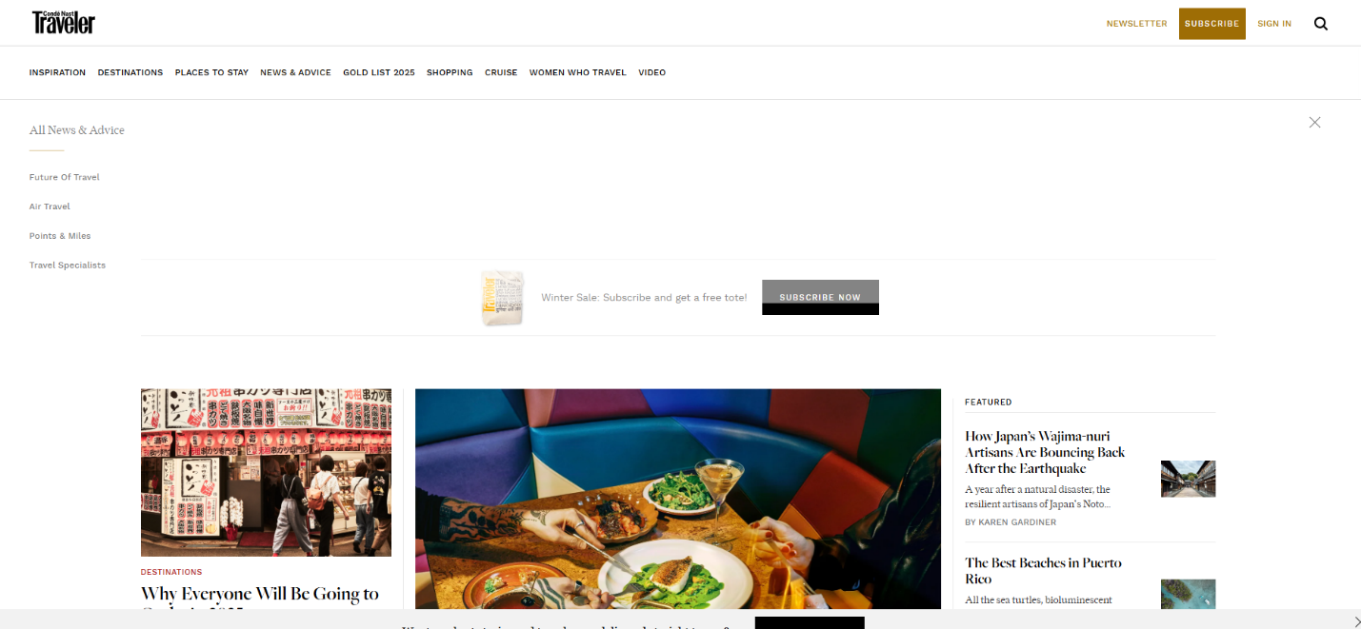

**Why it’s effective:**

* **Minimalist & Elegant Design** – Uses a clean, **image-driven layout** with well-organized sections.
* **User-Centric Navigation** – The menu is categorized by **destinations, travel guides, experiences, and news**.
* **SEO & Performance Optimization** – Optimized for **fast load times**, featuring **lazy-loading images** and **lightweight elements**.
* **Plugins for Functionality** – Implements features like **interactive maps, social sharing tools, and email subscription pop-ups**.

**2. TravelAwaits (**[**https://www.travelawaits.com/**](https://www.travelawaits.com/)**)**

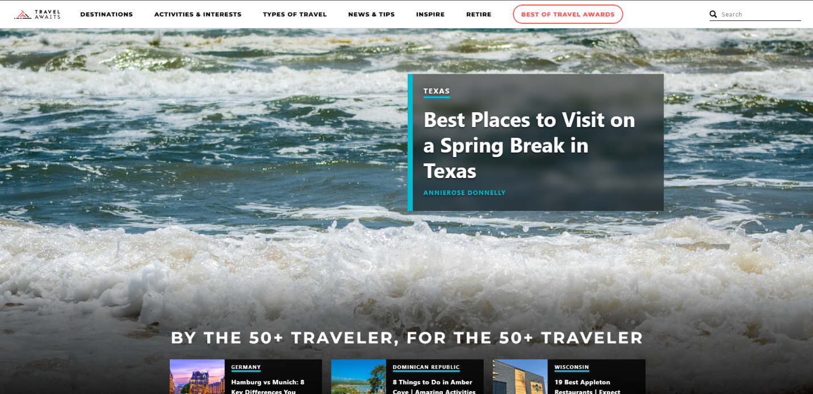

**Why it’s effective:**

* **Grid-Based Layout for Storytelling** – Uses a well-structured layout with **featured articles**, travel lists, and trending topics.
* **Robust Search & Filtering** – Includes **search filters** for finding destinations based on traveler preferences.
* **Dynamic Content Blocks** – Uses content blocks for **editor’s picks, top destinations, and seasonal recommendations**.
* **Optimized for Accessibility** – Features **large, readable fonts**, **alt text for images**, and **high-contrast elements**.

**Analysis of the Site’s Design Strategy**

**1. Theme (Layout)**

* The site uses the **Inspiro Theme by WPZOOM**, which is:
  + **Visually appealing** – Focuses on **full-width images and a clean design**.
  + **Responsive** – Ensures a **mobile-friendly experience**.
  + **Ideal for multimedia content** – Supports **videos and high-quality images** without slowing down performance.

**2. Plugins Used**

The images show the **WordPress plugins** installed on the site:

|  |  |
| --- | --- |
| **Plugin Name** | **Functionality** |
| **Google Analytics by MonsterInsights** | Tracks user engagement and site traffic. |
| **Site Kit by Google** | Integrates Google Search Console, AdSense, and Analytics. |
| **TaxoPress** | Manages tags and taxonomies for better content organization. |
| **WP Headers and Footers** | Allows inserting custom code (e.g., tracking pixels, scripts). |

These plugins help in **analyzing performance, improving SEO, and organizing content effectively**.

**3. Menu Structure**

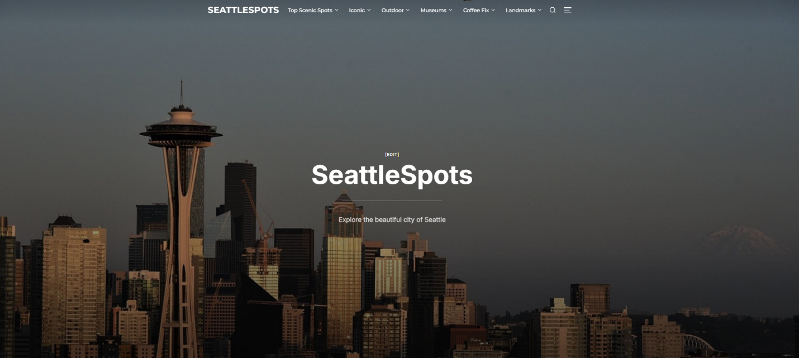

* The **menu follows a structured hierarchy**, categorized as:
  + **Top Scenic Spots**
  + **Iconic Attractions**
  + **Outdoor Adventures**
  + **Museums**
  + **Landmarks**
  + **Coffee Culture**
* Each category contains **sub-items** linking to specific articles, enhancing **user navigation and experience**.

**Comparison to Conde Nast Traveler & TravelAwaits**

The **site’s design strategy** shares similarities with these industry leaders:

* **Like Conde Nast Traveler:** Uses **a visually engaging, minimalist layout** with an emphasis on **images and readability**.
* **Like TravelAwaits:** Features **well-organized content categories** and **structured navigation**.

***8. Site Metrics Strategy: multiple paragraphs with images***

* 1. ***Discuss team's Explore Template(s) from GA4 'Explore | Analysis'***

Our team leverages the **Funnel Exploration** template in GA4 to analyze user behavior across key website interactions, tracking their journey from visiting the homepage to engaging with content. The funnel examines user progression through actions such as clicking on a blog post, scrolling and clicking “Read More,”.

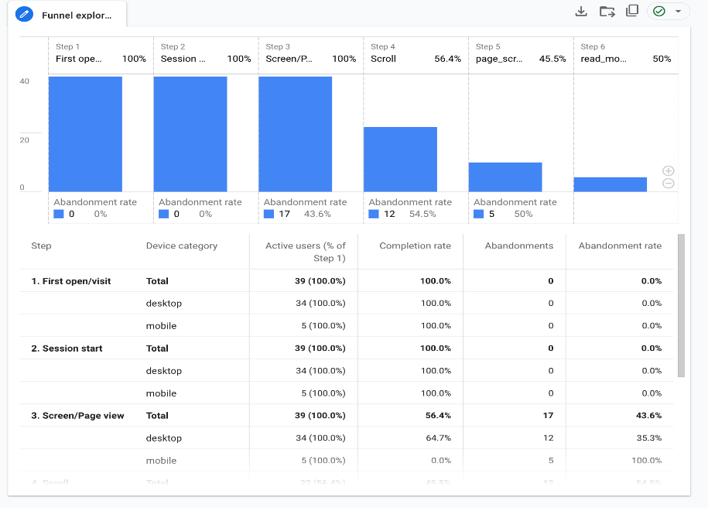

Our analysis highlights significant drop-off points, notably at the scrolling stage, where user count drops from 22 to 10, and in deeper engagement, as only three users click “Read More.” To address these issues, we are thinking of enhancing scroll engagement by incorporating compelling headlines, visuals, and interactive elements, as well as A/B testing different page layouts.

Additionally, improving “Read More” click-through rates can be achieved by making the button more prominent through size, color, or positioning and experimenting with stronger CTA wording like “Explore More” or “Start Now.” These optimizations aim to refine our content strategy, improve user retention, and enhance overall engagement.

* 1. ***Discuss team's 'Events' in GA4***

The GA4 Events report showcases key interactions that users have with our website, including page views, user engagement, scrolling behavior, and session starts. Over the last 28 days, the total event count reached 900 across 44 users, indicating that users are actively engaging with the site. Notably, “page_view” and “user_engagement” are the most frequent events, suggesting that visitors are spending time exploring multiple pages and interacting with content. The steady increase in event activity toward the end of the reporting period reflects growing user interest.

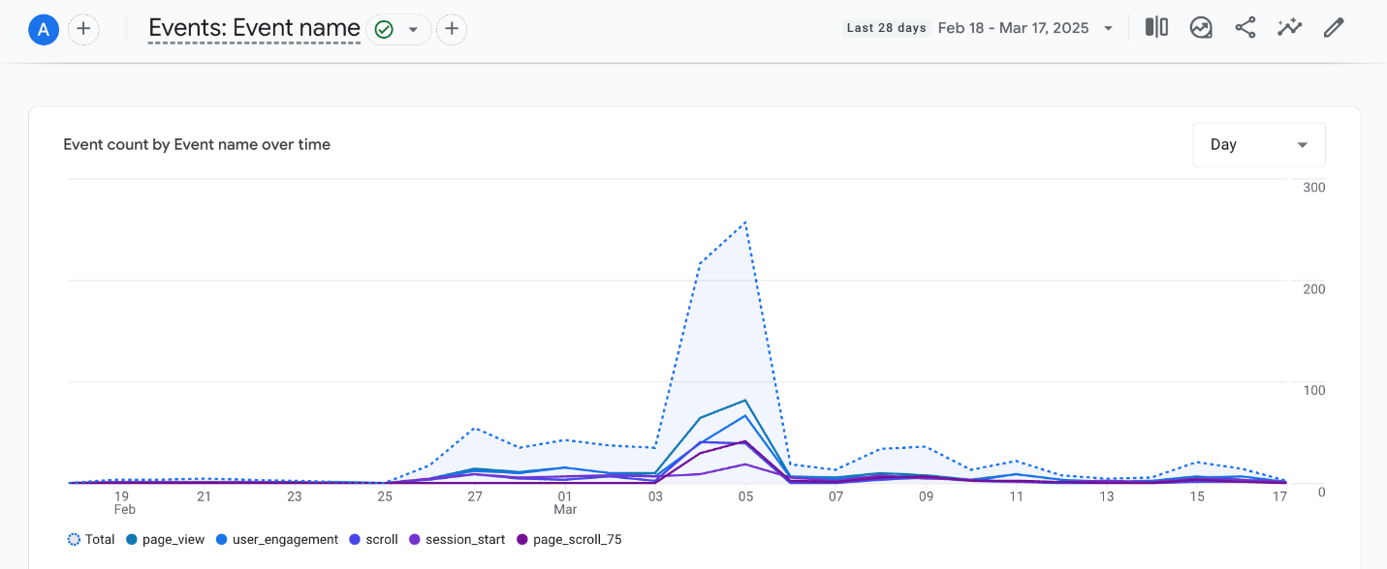

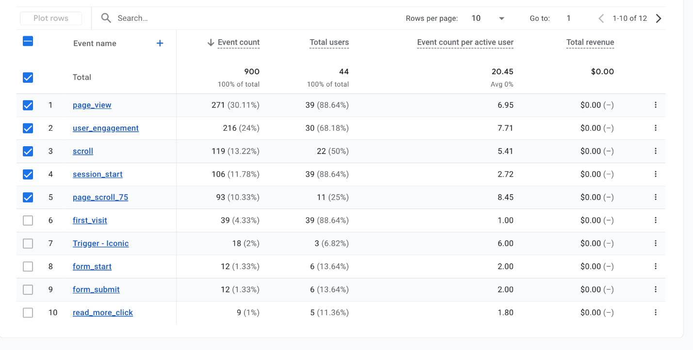

Specific event interactions, such as “scroll” and “first_visit,” help us measure audience behavior beyond just page views. The presence of “form_submit” events indicates that users are engaging with interactive elements such as commenting on our posts. The “read_more_click” event further highlights user interest in diving deeper into content. Understanding these events helps us identify which features drive engagement and which areas might need improvement. Additionally, page_scroll_75 captures when users scroll 75% down a page, providing insights into how much content is being consumed.

By analyzing these event trends, we can refine our user experience strategy to encourage more meaningful interactions. For example, if high scroll depth and engagement time correlate with certain types of content, we can focus on producing more of that content. These event-driven analytics help us understand how users interact with the website, allowing us to optimize content layout, engagement strategies, and overall user experience.

***9. Preliminary Analysis:***

1. ***Observe/examine your metrics. Describe what is happening.***

Our team has analyzed the Google Analytics reports for our WordPress website, and the data shows promising growth in user engagement. Over the past 3 weeks, we had 44 active users, with a significant spike in the past week (39 users) and 10 users around Mar 5. This conistent trend suggests increased interest in our content, likely due to improved visibility. However, to sustain this momentum, we should explore strategies to keep our audience engaged and encourage repeat visits.

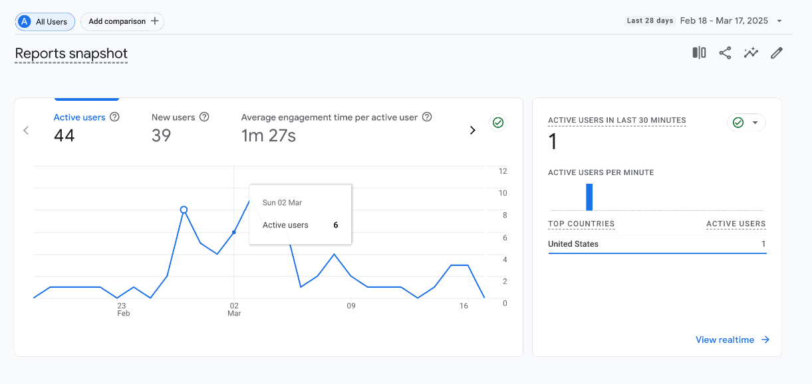

When looking at our top-performing pages, **“SeattleSpots – Explore the beautiful...”** leads with 142 views, followed by **“Top 3 Iconic Attractions in Seattle” (32 views).** Other pages, like **“Top Scenic Spots – SeattleSpots” (16 views)** and **“Seattle’s Best Outdoor Attractions” (11 views),** have considerably lower traffic. This highlights the need to optimize or promote less-visited pages through better internal linking or keyword adjustments. Additionally, our event tracking shows strong engagement with **271 page views, 216 engagement events, and 119 scroll events,** indicating that visitors are interacting with our content rather than bouncing off immediately.

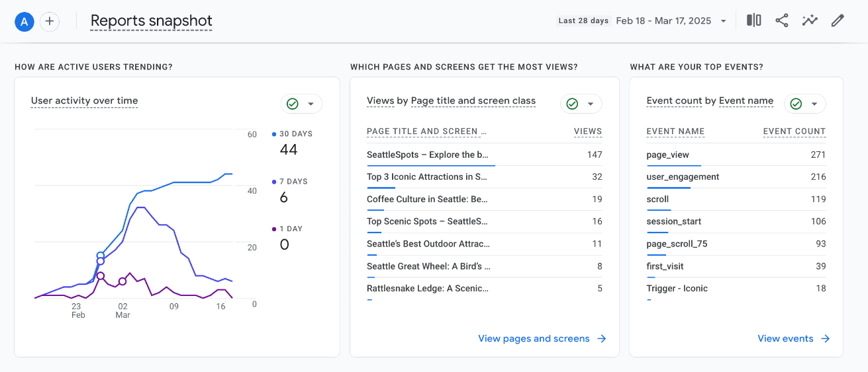

To capitalize on this momentum, we can implement a few key strategies:

* **Enhance internal linking** to guide users from high-traffic pages to those with lower engagement.
* **Improve CTA placements** on popular pages to drive deeper interactions.

1. ***Discuss how the team responds/aligns site Content Strategy with analytical insights***

Based on data trends, our team can refine the content strategy by addressing key areas of improvement. If certain pages exhibit a high bounce rate, we must identify whether the issue stems from unengaging content, slow page load times, or irrelevant information. Pages with high exit rates require closer examination to determine if users are leaving due to a lack of compelling content or navigational difficulties.

To address these issues, we can enhance content clarity, introduce interactive elements, and refine the page structure to improve readability and engagement. Additionally, analyzing user engagement metrics, such as the most viewed and interacted-with blog posts, can help us tailor our content strategy. If specific topics, such as "Best Travel Destinations in 2025," generate significant traffic and shares, we can prioritize creating similar content to align with audience interests.

Incorporating multimedia elements such as images, infographics, and videos can further boost engagement by making the content more visually appealing and informative. Through these adjustments, we can ensure that our content remains relevant, engaging, and aligned with user preferences.

1. ***Discuss how the team responds/aligns site Design Strategy with analytical insights***

Analyzing user behavior and engagement metrics allows the team to refine the website’s design strategy to enhance user experience and retention. If data indicates a high drop-off rate on specific pages, we must assess whether poor navigation, cluttered layouts, or unresponsive design elements are contributing factors.

To address these challenges, optimizing site navigation, and ensuring a clean, intuitive layout can significantly enhance usability. Additionally, if users are not interacting with key elements, such as call-to-action buttons or interactive features, adjustments in visual hierarchy, button placement, and contrast can drive better engagement.

Heatmaps and session recordings can further provide insights into user behavior, helping us identify design bottlenecks and areas for improvement. By continuously iterating based on analytical findings, we can create a visually appealing, user-friendly design that aligns with audience expectations and enhances overall site performance.

**10. KPI - Key Performance Indicators**

1. **Summary of KPI for team site**

The KPI table outlines key performance indicators (KPIs) that help track and improve the effectiveness of the Seattle Travel Spots website. It focuses on six primary goals: enhancing user engagement, increasing content interaction, attracting new visitors, measuring CTA effectiveness, tracking lead generation, and analyzing overall site activity. Each goal is linked to specific KPIs, such as average page views per user, scroll depth percentage, new vs. returning visitors, and form submission rates. Metrics like event counts and click-through rates provide quantitative insights into how users interact with the website, helping to optimize content strategy and improve engagement.

1. **KPI table**

|  |  |  |
| --- | --- | --- |
| **Goal** | **KPIs** | **Metrics** |
| Improve User Engagement | Avg. page views per user | Average Page View per User |
| Increase Content Interaction | Scroll depth percentage | Event Count |
| Grow New Visitors | New vs. Returning Visitors | Event Count |
| Measure CTA Effectiveness | Click-through rate on ‘Read More’ | Event Count |
| Track Lead Generation | Form submission rate | Event Count |
| Overall Site Activity | Total event count & active users | Event Count |

1. **Summary of Report in Google Looker Studio**

The Looker Studio report provides a comprehensive visualization of key website performance metrics, offering actionable insights into user engagement, content interaction, and overall site activity. It tracks essential KPIs such as page views, user engagement, scroll depth, CTA effectiveness, and form submissions. The report utilizes diverse chart types—including time series for trend analysis, bar charts for event comparisons, and funnel charts for conversion tracking—to present data in an intuitive and engaging manner. By leveraging these visualizations, the report enables stakeholders to identify areas for improvement, optimize content strategies, and enhance user experience effectively.

1. **Shared link of Google Looker Studio Report**

<https://lookerstudio.google.com/u/0/reporting/d9c78289-9305-4f01-bc7f-538de217f0de/page/WfTDF>

1. **A screenshot of Google Looker Studio Report**

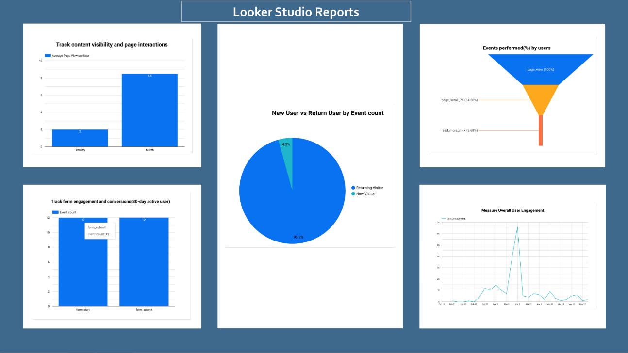

**11. Everyday Dashboard Exercise: Provide one page summary of everyday activity for your client - how to read and react from the daily Google Looker Studio Report**

#### **Overview**

The website **SeattleSpots** is focused on providing information about scenic locations, landmarks, outdoor activities, and museums in Seattle. Based on the Google Looker Studio report, we analyzed key performance metrics and user behavior patterns to offer tailored insights.

### **1. Measure Overall User Engagement**

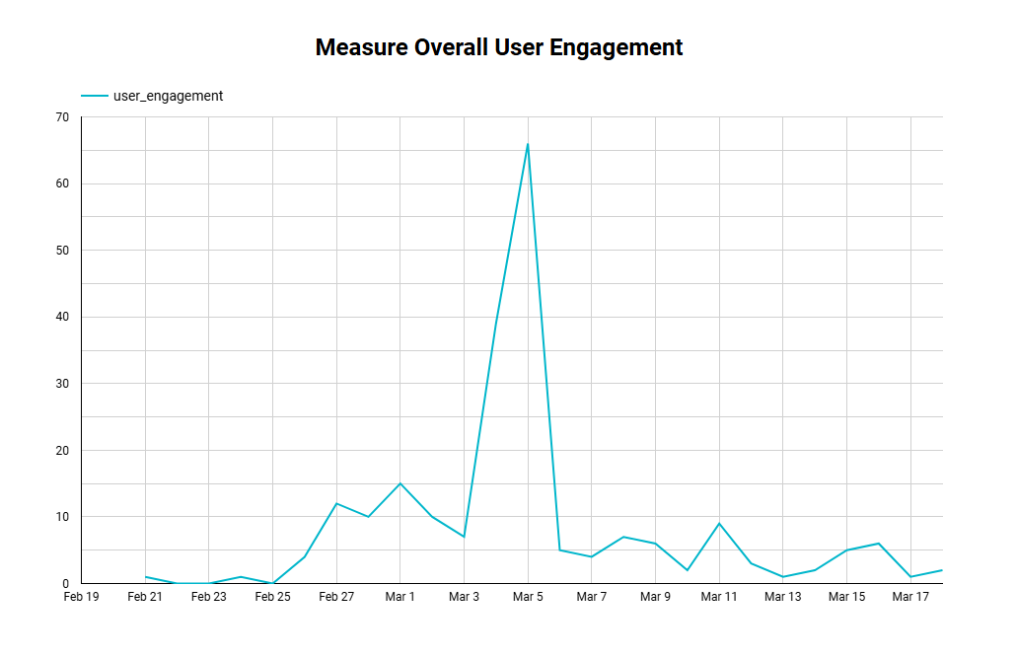

* **(a) Meaning:**
  + Tracks how often and how long users engage with our site.
  + A spike in engagement (e.g., March 5-6) suggests a popular content piece.
* **(b) Guidelines:**
  + If engagement increases → Identify successful content and replicate strategies.
  + If engagement drops → Optimize high-traffic pages, refresh content, and enhance navigation.

### **2. Track Content Visibility and Page Interactions**

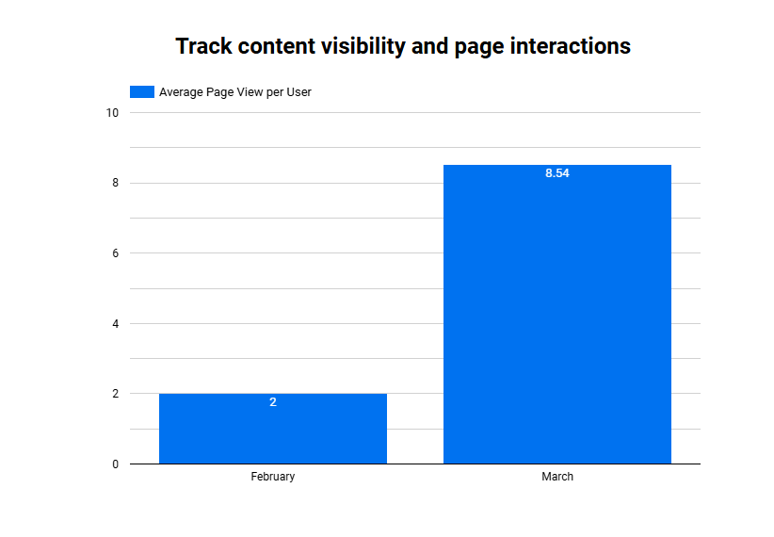

* **(a) Meaning:**
  + Measures how many pages a user visits per session.
  + Increased from **2 pages per user (Feb) to 8.54 pages (March)** → strong growth.
* **(b) Guidelines:**
  + High page views → Maintain quality content and internal linking.
  + Low page views → Improve **SEO, social media promotion, and user experience**.

### **3. New vs Returning Users**

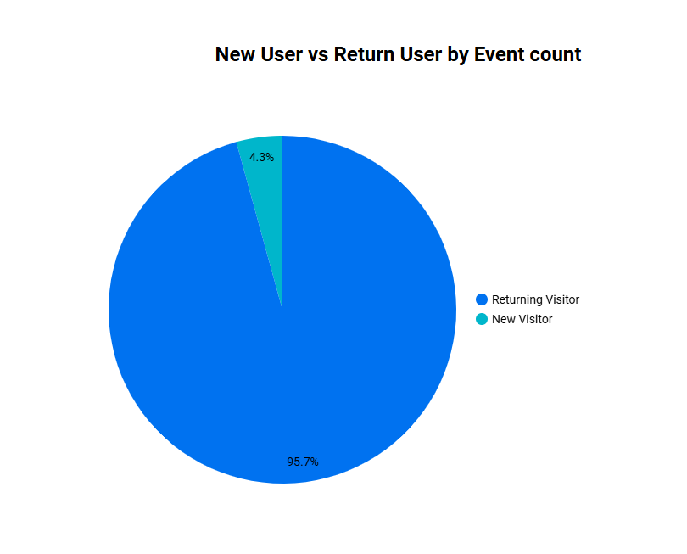

* **(a) Meaning:**
  + **95.7% of visitors are returning users**, only **4.3% are new**.
* **(b) Guidelines:**
  + High returning rate → Strong brand loyalty.
  + Low new users → Improve acquisition via **SEO, ads, and collaborations**.

### **4. User Actions – Funnel Performance**

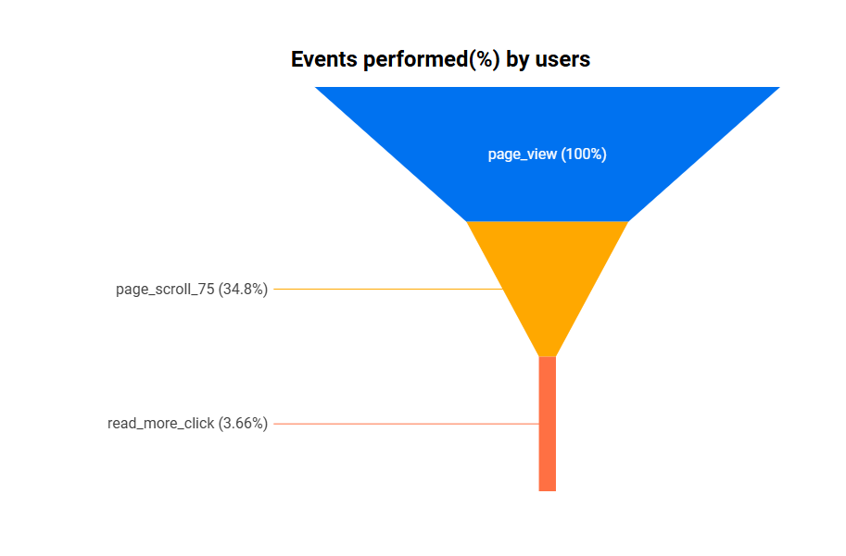

* **(a) Meaning:**
  + **100% of visitors view pages**, but only **34.8% scroll 75% of the page**, and **3.66% click to read more**.
* **(b) Guidelines:**
  + Low interaction rates → Use better calls-to-action (CTAs), optimize readability, and improve layout.

### **5. Track Form Engagement and Conversions**

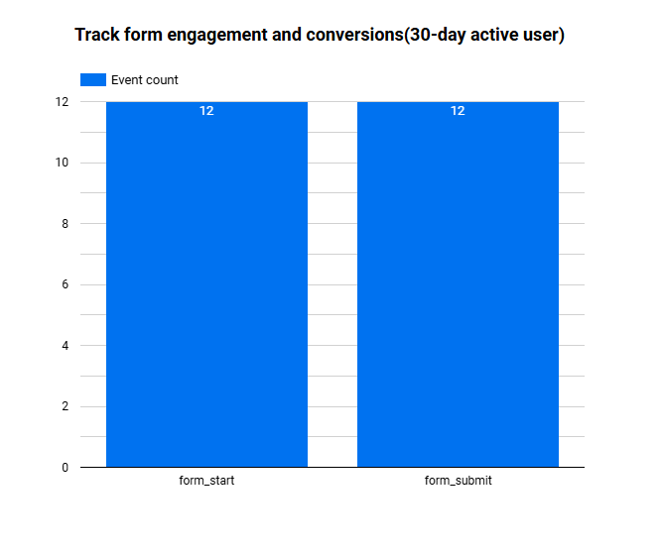

* **(a) Meaning:**
  + Users started and submitted forms **12 times each** – **100% conversion rate**.
* **(b) Guidelines:**
  + Good completion rate → Make forms more visible.
  + Low total form starts → Improve CTA placement and incentive messaging.

References:

* HubSpot. (n.d.). Interactive content examples to boost engagement. Retrieved February 19, 2025, from <https://blog.hubspot.com/marketing/interactive-content-examples>
* Moz. (n.d.). SEO for travel websites: Strategies for boosting visibility. Retrieved February 19, 2025, from <https://moz.com/blog/seo-travel>
* State of Washington Tourism. (n.d.). Explore Washington. Retrieved February 19, 2025, from <https://stateofwatourism.com/>
* Visit Seattle. (n.d.). Official Seattle travel and tourism guide. Retrieved February 19, 2025, from <https://visitseattle.org/>